**Anamoly Detection**

This project is about detecting anamoly in such as lose circuit, tyre jammed for robot car and sending it over IBM cloud.

Hardware used: Raspberry pi, Adxl345

Adxl345 is mounted over a robot and connected to raspberry pi which will detect change in acceleration along x, y and z direction.

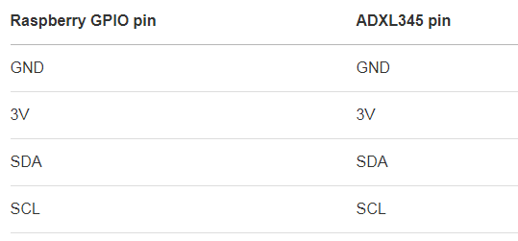

For every minute, mean, mode, median, standard deviation is calculated for acceleration along x, y and z direction individually.

Then, Threshold is decided on the basis in which direction major change is observed during anamoly.

This threshold will act as a decision point for detecting anamoly.

And Raspberry Pi is used to publish all this data on IBM Watson.

**Reference:**

To connect Adxl345 to RaspberryPi:

1. <https://www.anstack.com/blog/2016/07/05/accelerometer-intro.html>

IBM cloud Device link:

1. <https://1ltobn.internetofthings.ibmcloud.com/dashboard/devices/browse>

To create Device on IBM watson:

1. <https://developer.ibm.com/recipes/tutorials/how-to-register-devices-in-ibm-iot-foundation/>